**Week 34 Cod Temperature Preferences**

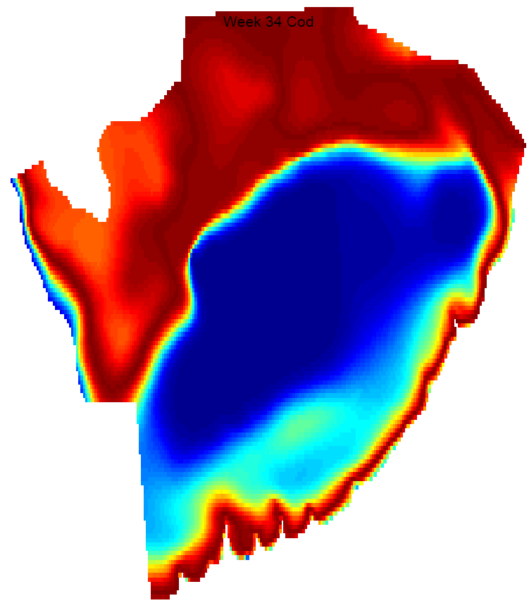

+

**Cod Habitat**

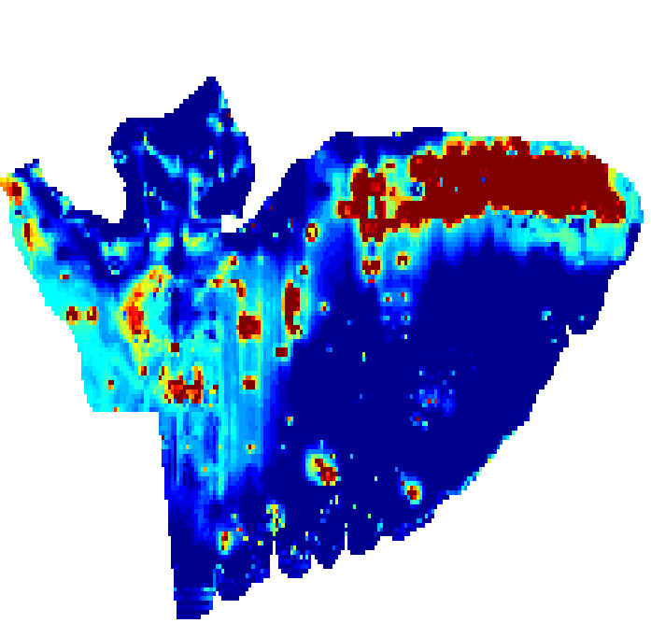

**Week 34 Cod Habitat**

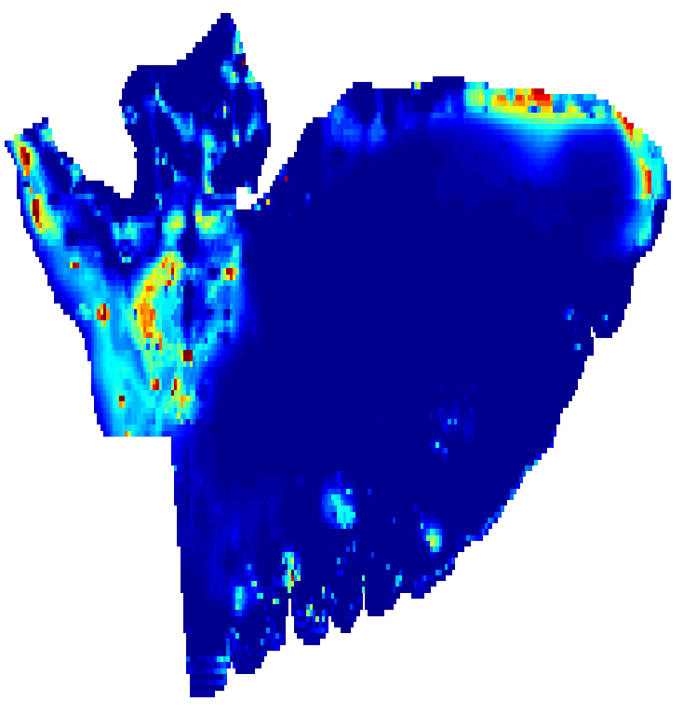

=

**Cod Habitat on George’s Bank**

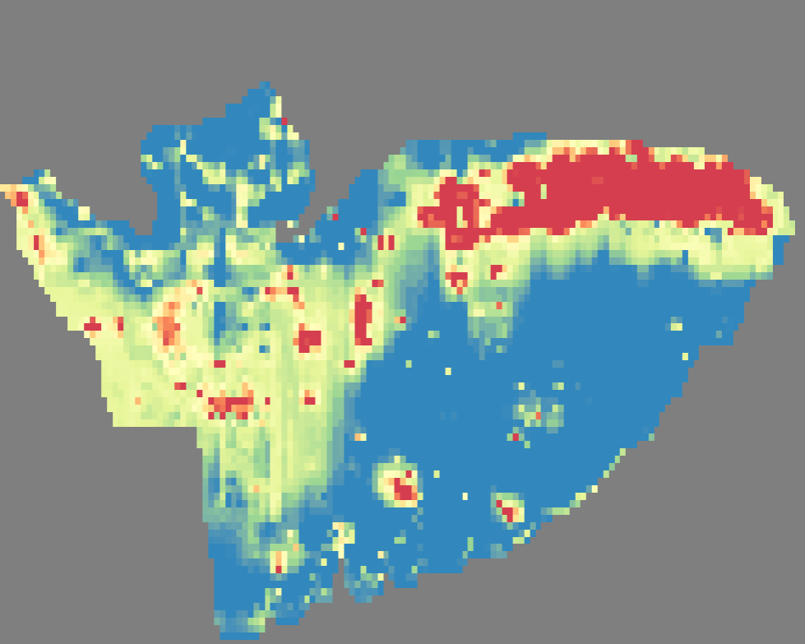

**Depth**

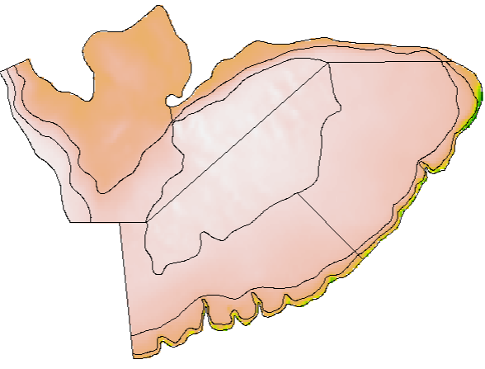

**Median Sediment Size**

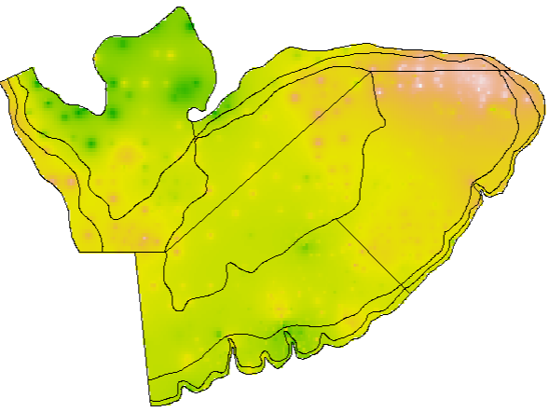

**Weighted Presence/Absence Data**

Model Niche

Relate to Covariates

